

Welcome to the Assembly Guide for the DropLit 3D printer.
Version 0.02, September 10th, 2014
Copyright 2014 by Gene Buckle
Licensed as Creative Commons Attribution-ShareAlike 3.0
Questions or corrections should be emailed to geneb@deltasoft.com
Disclaimer text provided by LulzBot

READ ME FIRST!

READ THIS MANUAL COMPLETELY BEFORE ASSEMBLING AND POWERING UP
YOUR PRINTER!

Hazards and Warnings

The SeeMeCNC DropLit 3D printer has motorized parts. When the printer is in operation always be aware of possible hazards.

Electric Shock Hazard

Never open the electronics bay of the printer while the printer is powered on. Before removing

the access door, always power down the printer and unplug the AC line cord.

Fire Hazard

Never place flammable materials or liquids on or near the printer when powered on or in

operation.

Pinch Hazard

When the printer is in operation, take care to never put your fingers in the moving parts,

including the belts, pulleys or gears. Also, tie back long hair or clothing that can get caught in

the moving parts of the printer.

Static Charge

Make sure to ground yourself before touching the printer, especially the electronics.

Electrostatic charges can damage electronic components. To ground yourself, touch a

grounded source.

Age Warning

For users under the age of 18, adult supervision is recommended. Beware of choking hazards

around small children.

Table of Contents
READ ME FIRST! 2
0 – Introduction and Acknowledgments 1
1 – Required and Optional Tools And Materials 3
2 – Visual Bill of Materials 7

0 – Introduction and Acknowledgments
I’d like to welcome you to the DropLit assembly guide!
Please read this entire guide before you begin assembly of your new DropLit! It will help you avoid any unpleasant surprises and will ensure that you’ve got everything you need BEFORE you need it! Understand that the photographs in this assembly guide do NOT tell the whole story of each step! Make sure you read and understand the accompanying text for each step!
A quick note on the Arduino Uno and the “grbl” Shield. These two devices work in combination to control the DropLit and are very static sensitive, so please don't take them out of the bags they ship in until you're ready to install them.

1 – Required and Optional Tools And Materials

Before you begin assembly of your Rostock MAX v2, please make sure you’ve got everything on the following list of tools and additional materials.
- P1 & P2 sized Phillips screwdrivers
- Standard flat head screwdriver
- Wire strippers
- Wire cutters
- Battery powered screwdriver. If you ever needed an excuse to buy one of these, THIS IS IT.
- Blue thread locking compound (Loctite or Permatex Threadlocker Blue)
- Waxed lacing cord. You can use this in place of wire ties in pretty much any application. You can find it here: http://www.skygeek.com/wht-string.html. While expensive, you'll never really need to buy a wire tie again and it'll likely last you the rest of your life. :)

2 – Visual Bill of Materials
Your DropLit kit should contain a wrapped pack of Melamine parts, three bags of parts (two bags of hardware, one bag of electronic parts) a short section of aluminum extrusion and a power supply.
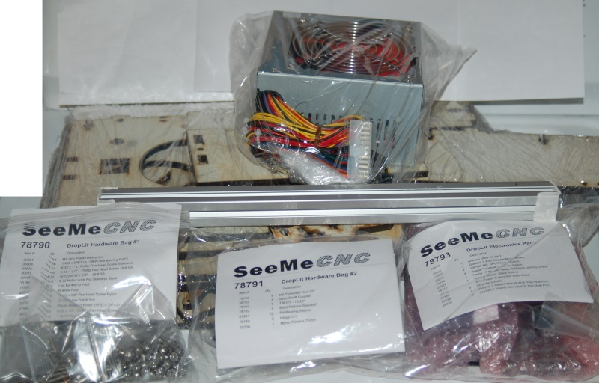Fig. 2-1: DropLit package contents.

The Melamine parts are covered with a special cutting mask that prevents the laser cutting operation from depositing cutting residue on the Melamine surface. You'll need to remove all of this material before beginning construction. This process is called the Five Stages of Masking Tape.
1. Denial - Oh there's no way I need to scrape all this tape off those parts? Do I?
2. Anger - @#$%@#! This sucks! I've NEVER SEEN SO MUCH TAPE IN ONE PLACE IN MY LIFE!
3. Bargaining - “Well hi there, Significant Other! Would you PLEASE remove all this tape for me? PLEASE?”
4. Depression - This tape hates me. *sobs quietly*
5. Acceptance - Well I suppose if I'm ever going to get this thing built, I'd better get on with it and get all this tape removed...*sigh*

Ok, it's not THAT bad, it just seems like it. It beats having sticky ash product all over your nice and clean Melamine parts. :)

For those that aren't sure how to identify the various screw types, Bolt Depot has made available some excellent references. I would recommend Fastener Basics (http://www.boltdepot.com/fastener-information/Printable-Tools/Fastener-Basics.pdf) and their Fastener Type Chart (http://www.boltdepot.com/fastener-information/Type-Chart.aspx).
DropLit Hardware Bag #1
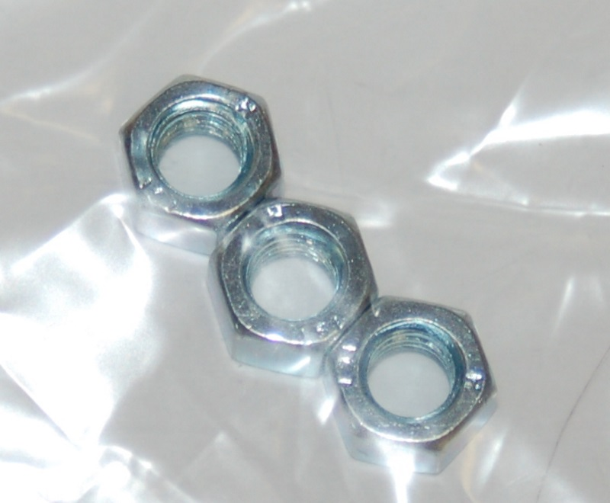
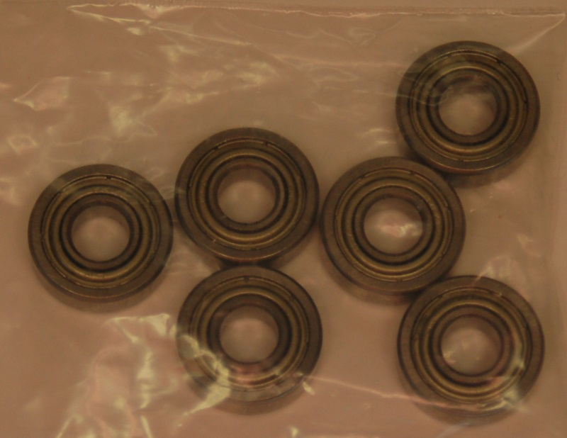
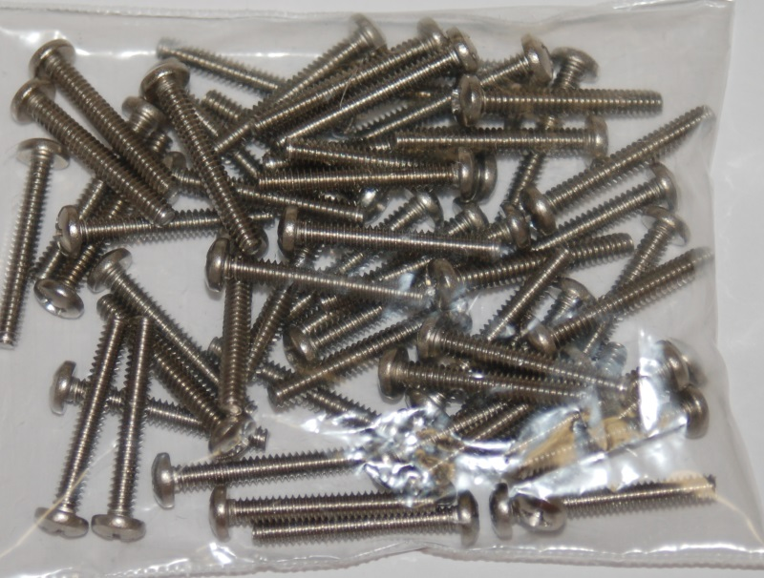
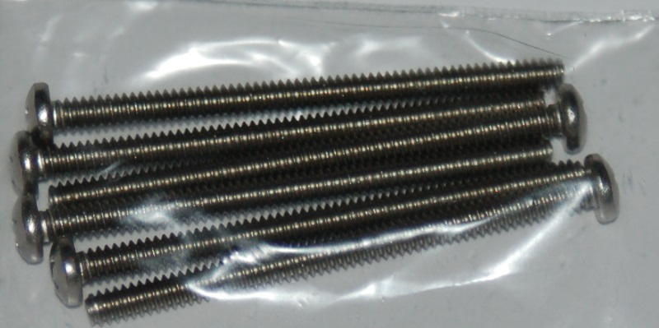
(___) (3) M5 Zinc Plated Nut

(___) (6) 1/4” ID x 5/8” OD x .196” Ball Bearing (R4ZZ)

(___) (57) #6-32 x 1” Phillips Pan Head Screw 18-8 SS

(___) (6) #6-32 x 2” Phillips Pan Head Screw 18-8 SS

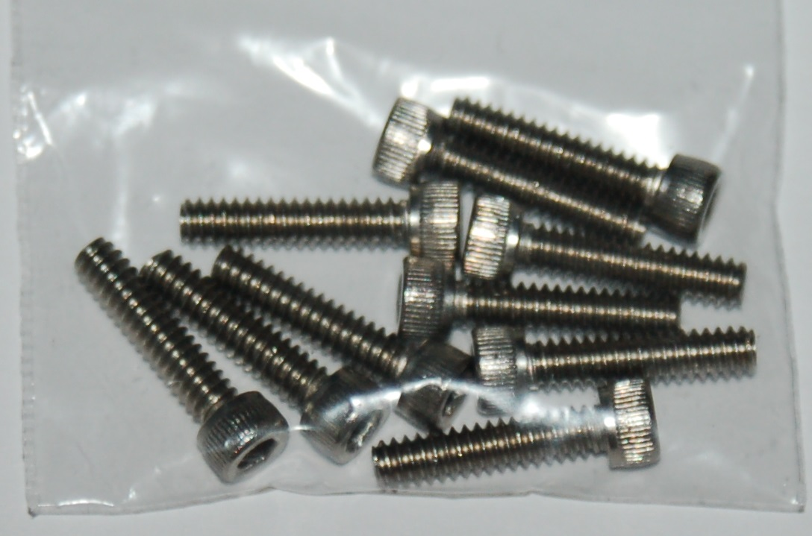
(___) (10) #6-32 x 5/8” Socket Head Cap Screw 18-8 SS

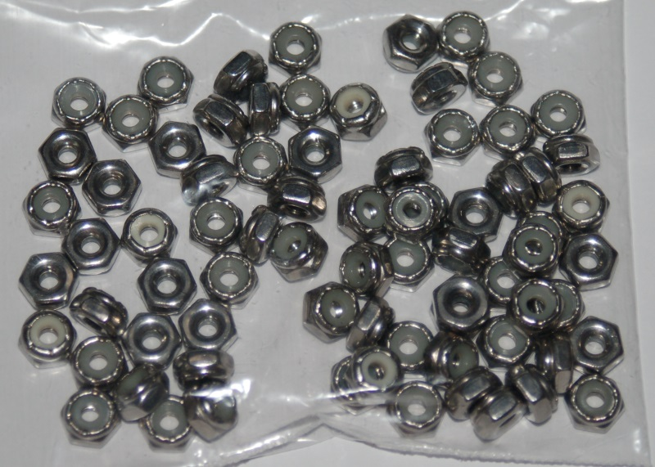
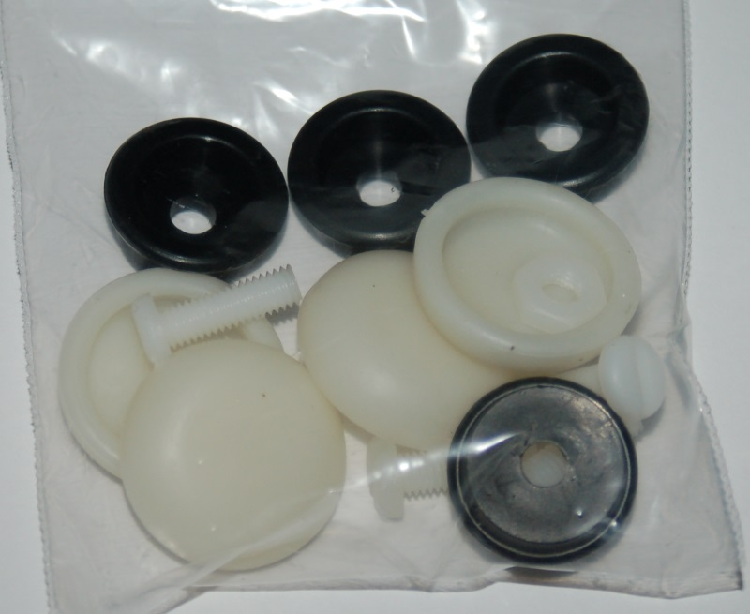
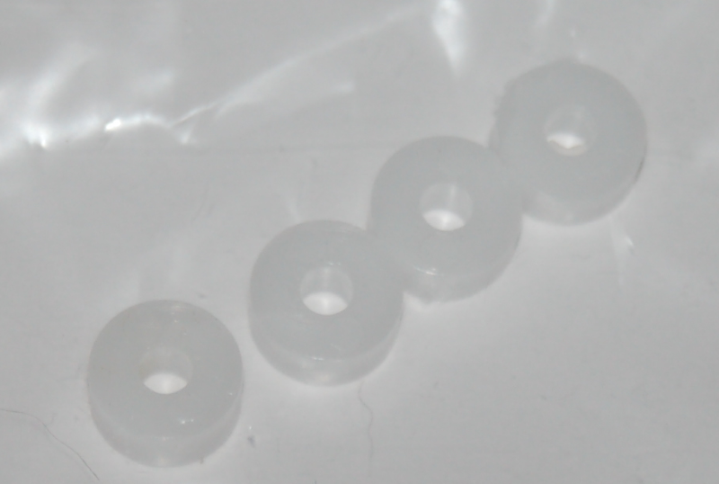
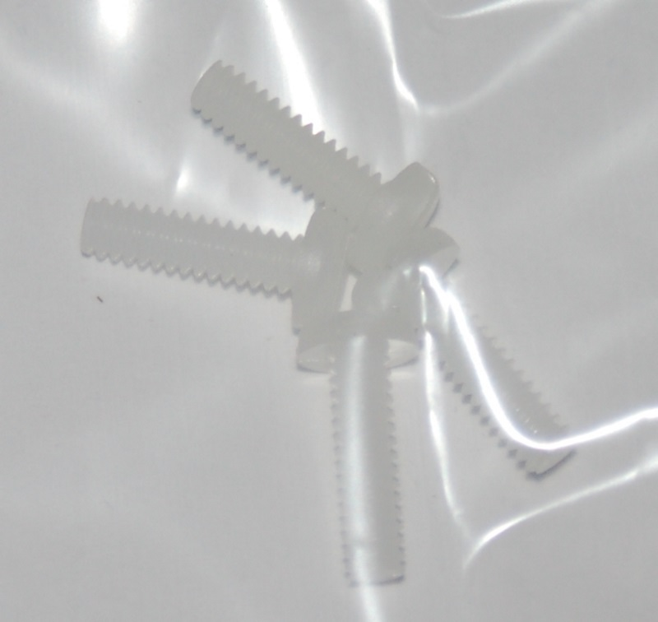
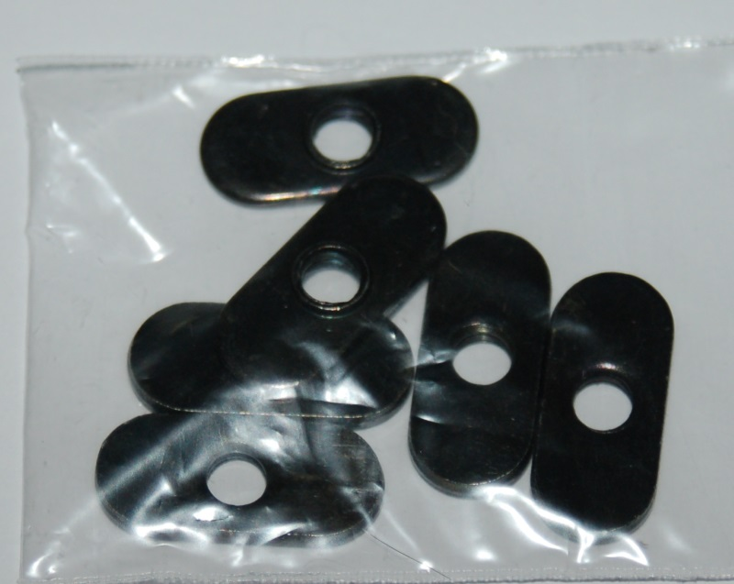
(___) (75) #6-32 Nylon Lock Nut SS

Rubber foot pack containing
(___) (4) Leg for 44010 Foot
(___) (4) Rubber Foot (44010)
(___) (4) #10-32 x 5/8” Pan Head Screw (Nylon)
(___) (4) #10-32 Nylon Finish Nut

(___) (4) Plastic Bearing Roller 1/8” ID x 3/8” OD x 0.156” W

(___) (4) #6-32 x 1/2” Slotted Pan Head Screw (Nylon)

(___) (6) 1/4-20 T-Slot Nut

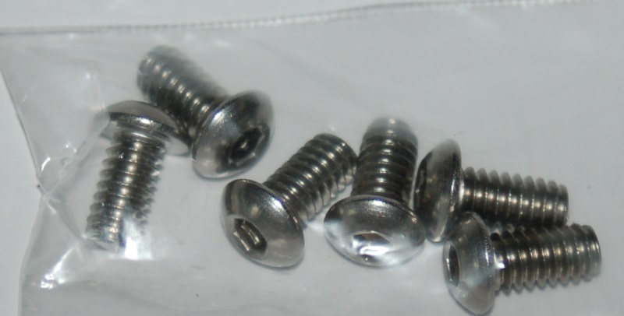
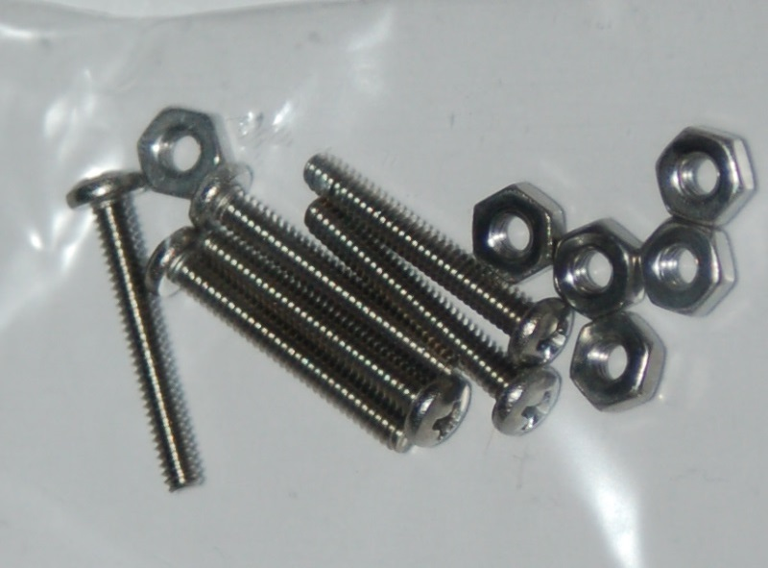
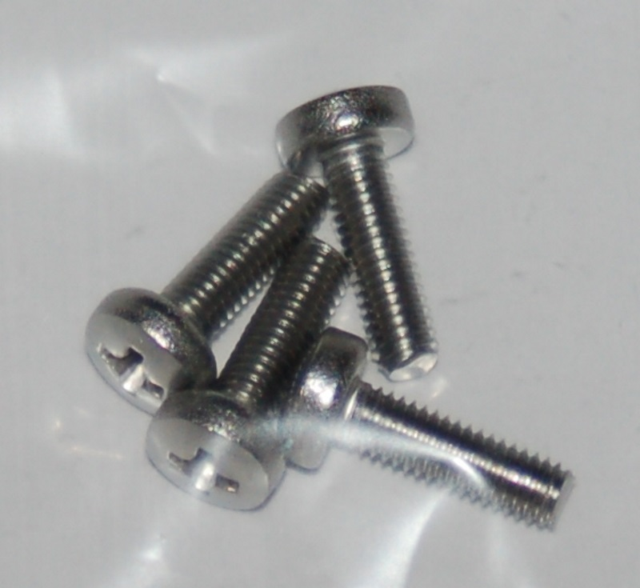
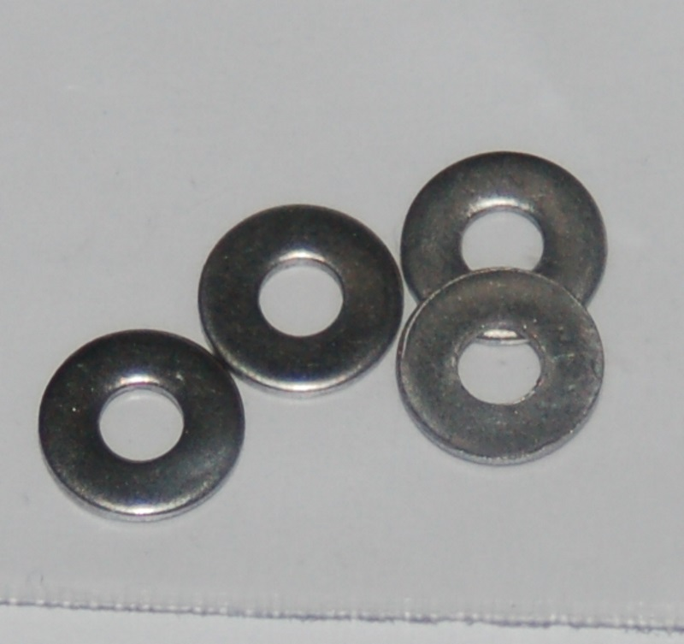
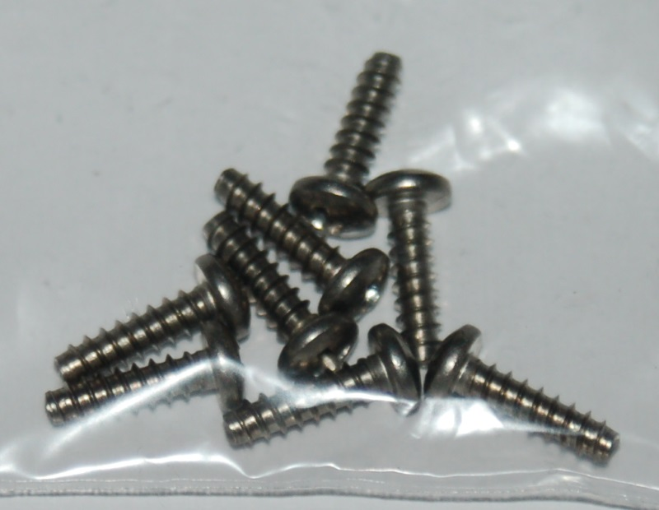
(___) (6) 1/4-20 x 1/2” Button Head Cap Screw (SS)

(___) (6) #2-56 x 5/8” Pan Head Screw
(___) (6) #2-56 Finish Nut

(___) (4) M3-.05 x 10mm Phillips Pan Head Screw (SS)

(___) (4) #4 SAE Flat Washer (SS)

(___) (8) #6 x 1/2” Phillips Pan Head Sheet Metal Screw (SS)

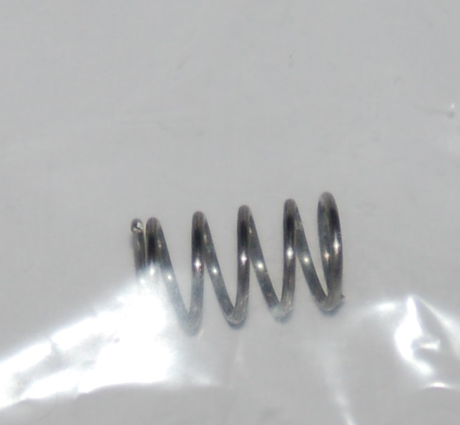
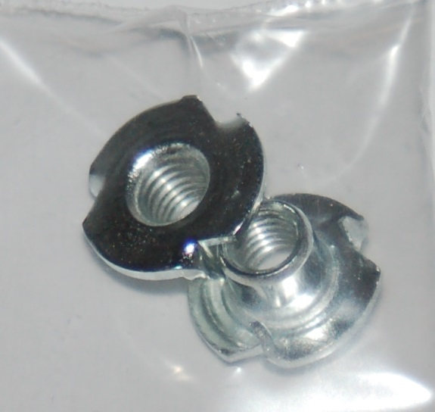
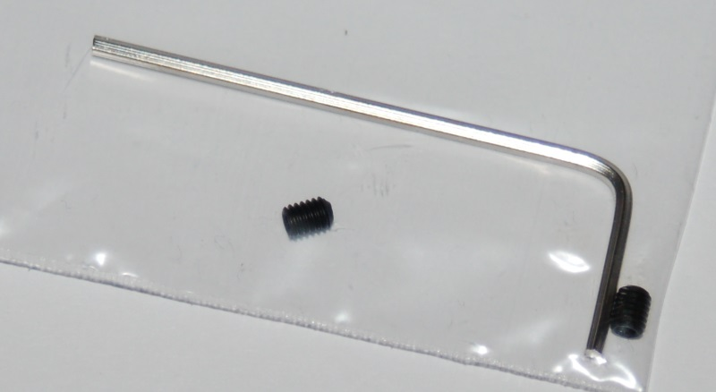
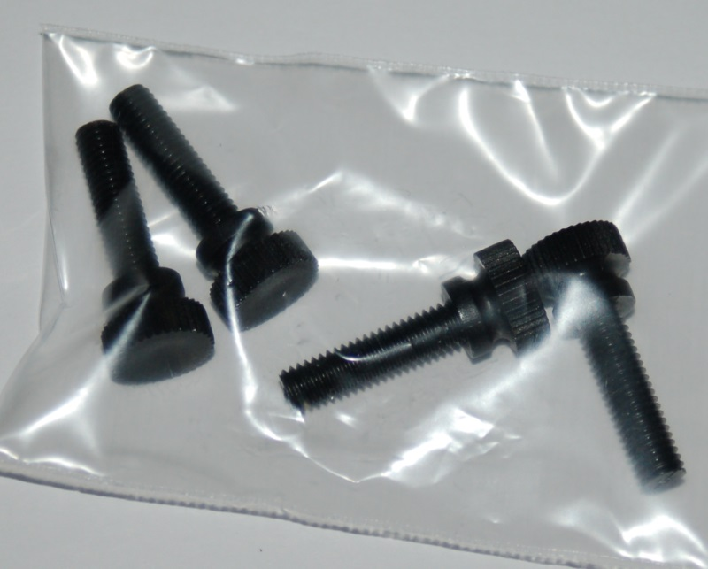
(___) (1) .300” OD x .030 wire x 1/2” SS Compression Spring

(___) (2) #10-32 T-Nut

(___) (2) M3-.5 x 6mm Allen Set Screw
(___) (1) 1.5mm Allen Wrench

(___) (4) #10-32 x 3/4” Knurled Thumb Screw (Black Nylon)

